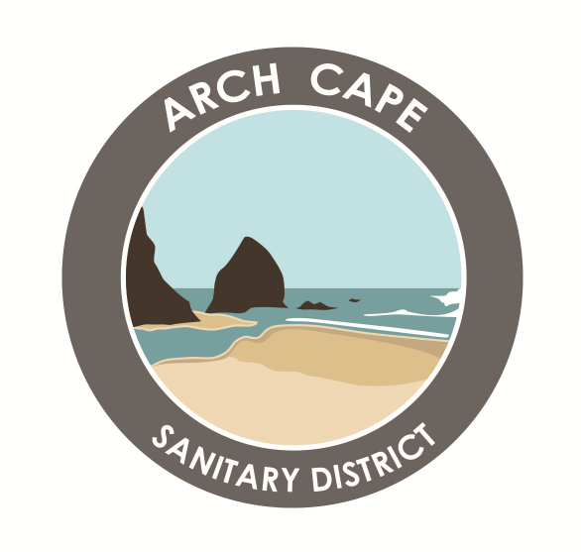
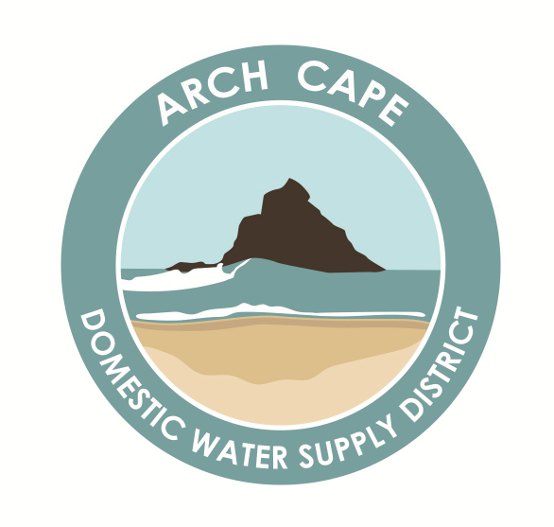

Budget &

Board Meetings
ARCH CAPE WATER & SANITARY DISTRICTS
32065 E. Shingle Mill Lane, Arch Cape, OR 97102
(503) 436-2790

THE PUBLIC IS INVITED, IF THEY WISH,
TO ATTEND IN PERSON:
THE FIRE HALL, 72979 US 101,
ARCH CAPE
BY TELEPHONE OR ZOOM LINK:
To Join the Zoom Video Meeting paste the following in your browser address window:
Board Meeting Zoom Link

Call: 669-900-6833
Meeting ID: 824 5089 8403
Meeting Passcode: None Required
Assistance: 503-812-7578
Date: Thursday, 18 May 2023
Time: 4:00 PM for Budget
BUDGET Zoom Link
6:00 PM for Board Meetings

Budget Meeting at 4:00 pm Sanitary District will be held first, followed by Domestic Water Supply District Meeting. Agenda will be posted in Board Packet on the Website under “Governance – Meetings – 2023”

